Micro Grant Program

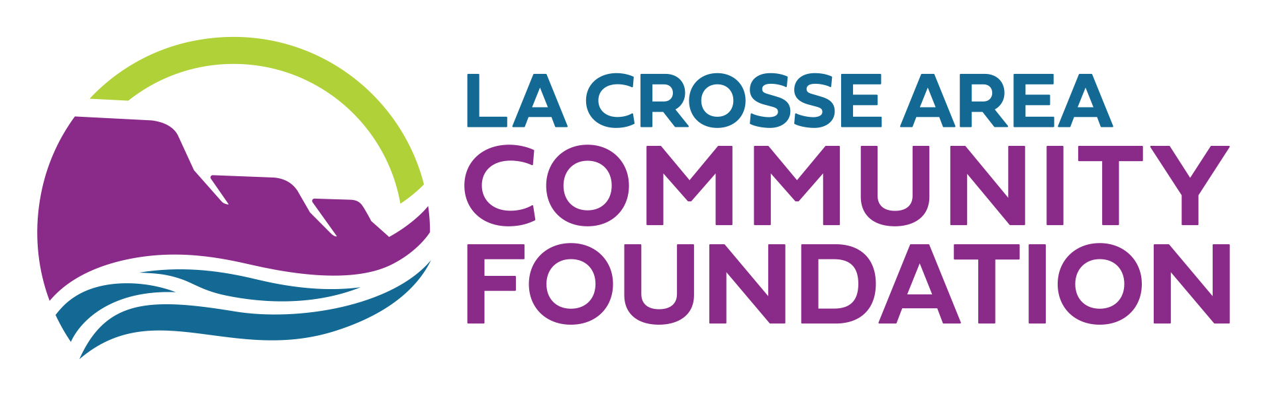

REQUEST FOR PROPOSALS

Micro grants are designed to be responsive to the needs of nonprofit organizations serving La Crosse County who may otherwise have limited access to resources. La Crosse Area Community Foundation has allocated $120,000 this year for nonprofits seeking awards of $250 - $3,000. One application per organization will be accepted. Contact keli@lacrosseareafoundation.org if more than one application is needed to accommodate fiscally sponsored applications.

Purpose of this Grant
La Crosse Area Community Foundation is committed to investing in our community’s diverse nonprofit sector including making funds more accessible to those with the least capacity and access to resources.

Organizational Eligibility
The primary eligibility criteria are:
- Applicant organization must be a public charity, exempt from federal income taxes under section 501(c)(3) of the Internal Revenue Code, or governmental bodies, including schools and municipalities, as long as the project is above and beyond regular budgeted items and does not fill budget gaps OR;
must have a formal fiscal sponsor relationship with an IRS verified 501(c)3 nonprofit.
- All K-12 schools in La Crosse County can apply for one micro grant per year, per school.
- Must be located in and primarily serve residents of La Crosse County.
- The organization has an annual operating budget of $500,000 or less.
- Agrees to meet all Grant Awardee Requirements & Expectations listed below.
- Organizations must comply with “Appendix A” of LACF’s DEIB Policy

Eligible Use of Funds
Micro Grants are designed to be easily accessible for immediate needs or to fill gaps in services/community engagement. Projects offering a new strategy, improved strategy, or to support growth to meet community needs/demand are encouraged.
Ineligible micro grant expenses include the following:
- Repeat grants to the same project on an open-ended basis
- Wages/Benefits
- Partisan political activities
- Organizational endowments
- Event sponsorships or annual fundraising campaigns
- Scholarships or grants to individuals
- Religious activities for the primary purpose of religious education or proselytization*
- Retroactive expenses or activities that occur before notification of an award
- Loan or debt payments
- Travel for groups such as clubs or sports teams (Schools may apply for travel expenses)
Limitations
Units of Government (city, county, township, etc.): The Foundation does occasionally fund units of
government whose proposal extends beyond the traditional governmental functions that impact the
broader community or when the request for support is judged to be an effective means to address a
priority issue.

*Proselytization: Participation in the funded program is dependent on required attendance at religious services or participation in religious study/instruction to access services and/or the purposeful intent to convert one's faith.

Applying for the Grant
Applications will be accepted on a rolling basis beginning January 20, 2026, and until funding is exhausted for the calendar year. Micro grant applications are reviewed on the 2nd Monday of the month. Applications received after the second Monday will be held for the next review cycle. Technical assistance will be available on an on-going basis to organizations who want to receive assistance in preparing their application. This process is anticipated to take 30 minutes or less.

RFP announced: December 1, 2025
Eligibility Quiz Open: January 20, 2026
(the eligibility quiz will determine if your organization meets the basic requirements for this grant and then the applicant is able to apply within the process if they are found eligible through the quiz)
Applications Open: January 20, 2026
Awards announced: As soon as possible; no more than 1 month from submission
Grant period begins: Upon award notification
Technical assistance contact: Keli Frigo, Impact Specialist | keli@lacrosseareafoundation.org | 608-782-3223 x29

Application Evaluation
To be responsive to the community’s needs, La Crosse Area Community Foundation’s Impact Department staff will review the following parts of each application for eligibility prior to approval:
- Budget submission
- Funding purpose alignment with organization’s mission
- Eligible use of funds
All approved applications will be shown to our Donor Advised Fundholders for an opportunity for them to fund your project. Once an application is approved for funding, the awarded organization will receive the funding, regardless of a DAF choosing to fund the project.
**The Impact Specialist, who facilitates the committee, does not participate in evaluating grant applications. We highly encourage applicants to seek technical assistance from the Impact Specialist, as needed, to support putting your best grant application forward.

Grant Awardee Requirements & Expectations
Grant awardees commit to the following engagement with La Crosse Area Community Foundation:
- Participation in a Nonprofit Networking session to share outcomes and successes from your micro grant and to learn about other organization’s projects at the same time. We anticipate facilitating these opportunities multiple times during the year.
- SAVE THE DATE:
  - Nonprofit Networking & Sharing | February 3, 2026, 4:30 pm
  - Nonprofit Networking & Sharing | May 6, 2026, TBA

